9/24/2026
LAB NO 03
Operating System
Instructor: Ms. Muneeba Banaras
Submitted By: Wasif Ali
Reg ID: 245187
Class: BSCS F’24 B

LAB TASK
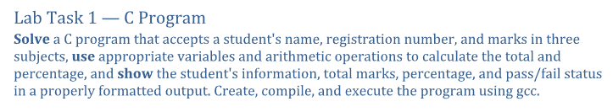
Working:
In this task, we created a C program named task1.c using nano. The program prompts the user to enter the student's name, registration number, and marks for three subjects using scanf. It calculates the total marks and percentage using arithmetic operators. An if-else block checks whether the percentage is $50\%$ or higher to set the pass/fail status. Finally, the program prints a formatted result card using printf. We compiled it using gcc task1.c -o task1 and ran ./task1 to verify the output.

Code and Result:
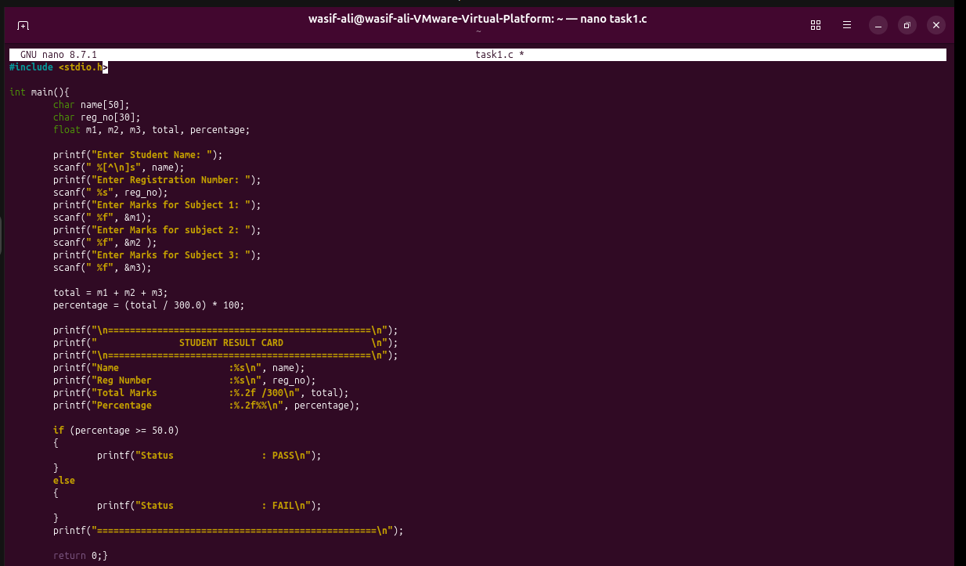

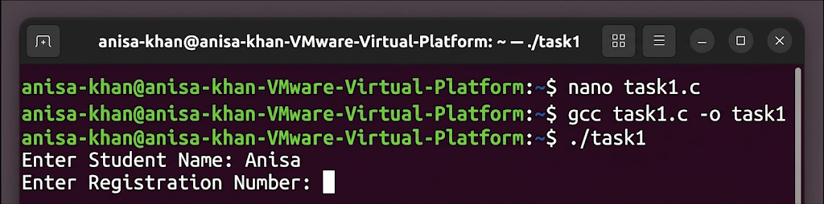
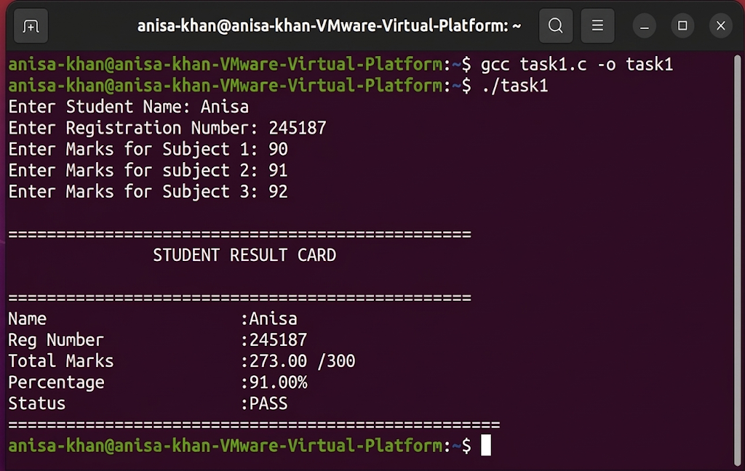

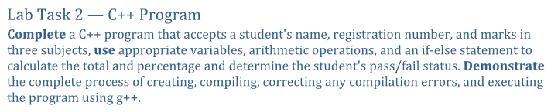
Working:
In this task, we developed a C++ program named task2.cpp. We used standard C++ input/output streams (cin and cout) to collect student details and marks. The program evaluates total marks, percentage, and pass/fail condition using an if-else statement. We demonstrated the complete compilation workflow using g++ task2.cpp -o task2 and executed the resulting binary via ./task2. Any compilation syntax errors (such as missing semicolons) were identified and corrected prior to final execution.
Code and Result:
